Lab#03 Recursion SSUET/QR/114

**LAB # 03**

**RECURSION**

# LAB TASKS:

1. Write a program which takes an integer value (k) as input and prints the sequence of numbers from k to 0 in descending order.

**Input:**

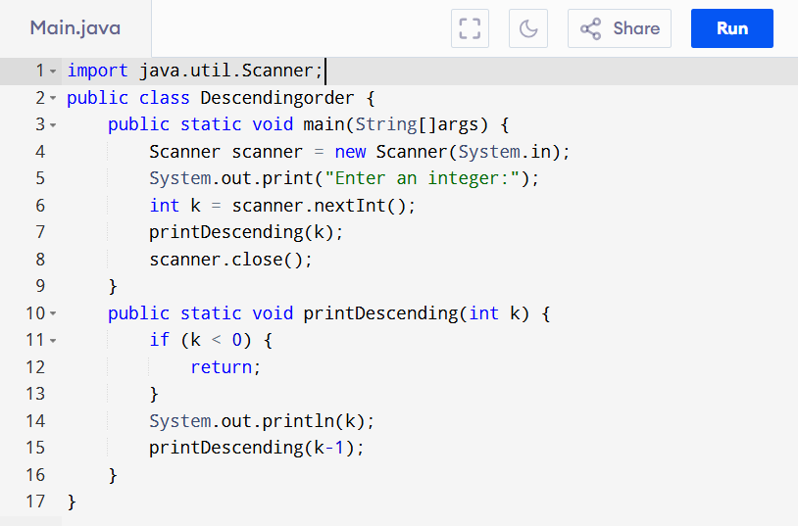

**Output:**

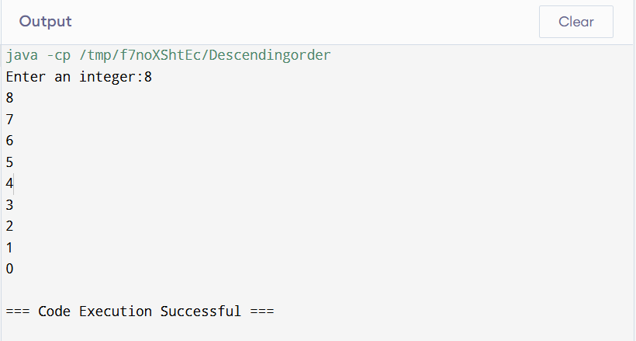

1. Write a program to reverse your full name using Recursion.

**Input:**

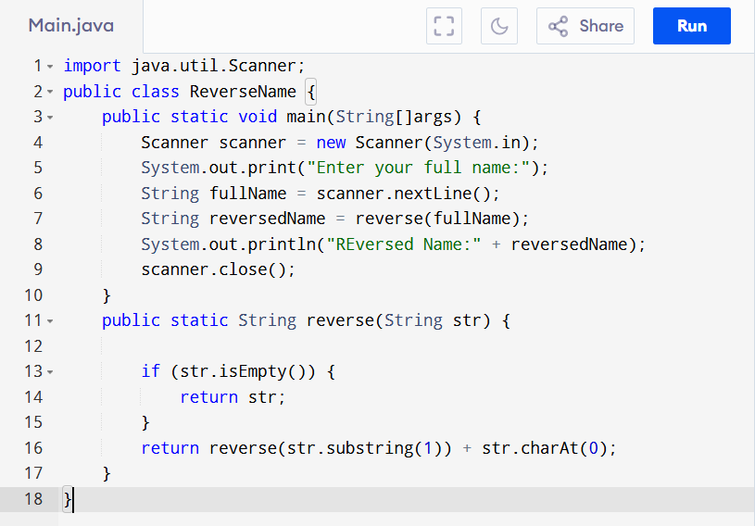

**Output:** 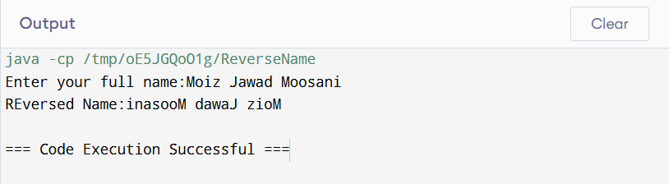

1. Write a program to calculate the sum of numbers from 1 to N using recursion. N should be user input.

**Input:**

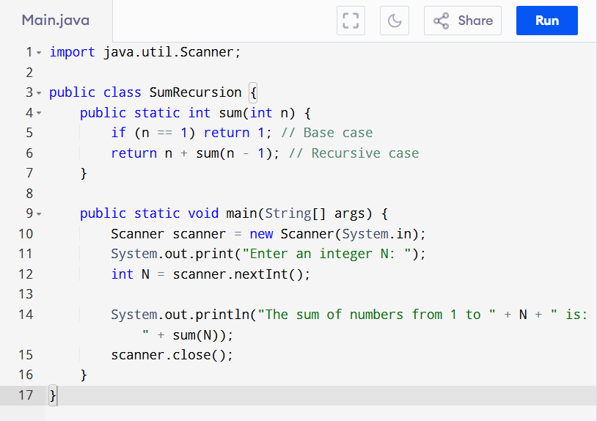

**Output:**

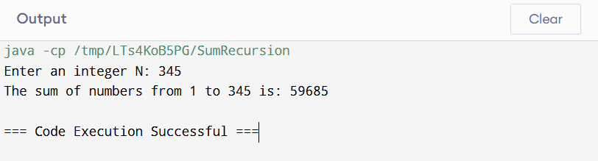

1. Write a recursive program to calculate the sum of elements in an array.

**Input:**

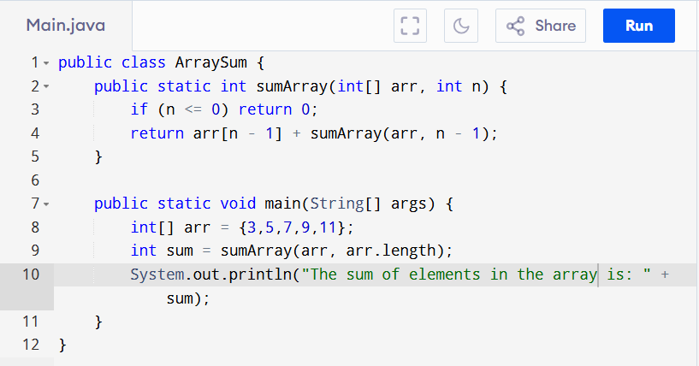

**Output:**

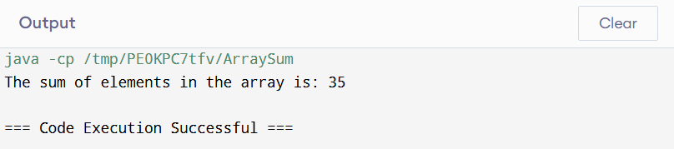

1. Write a recursive program to calculate the factorial of a given integer n

**Input:**

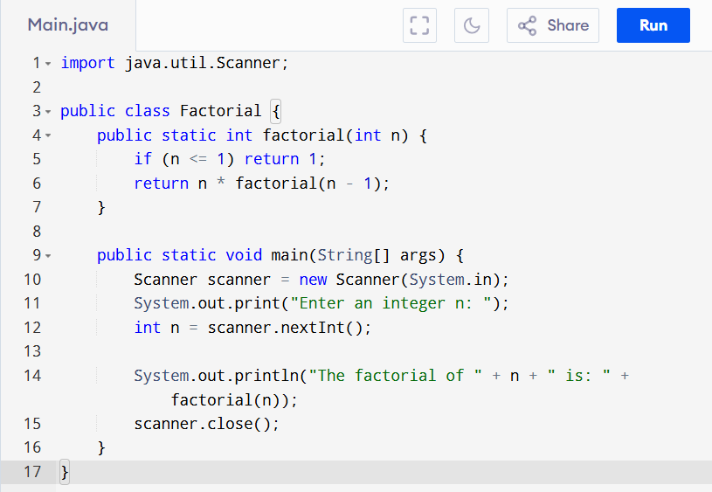

**Output:**

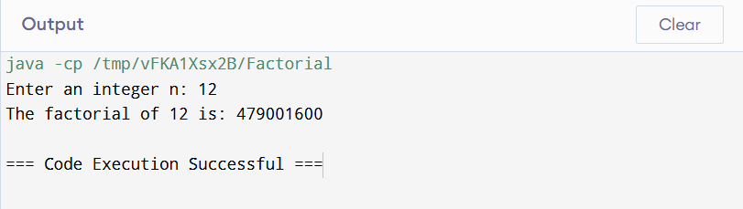

1. Write a program to count the digits of a given number using recursion.

**Input:**

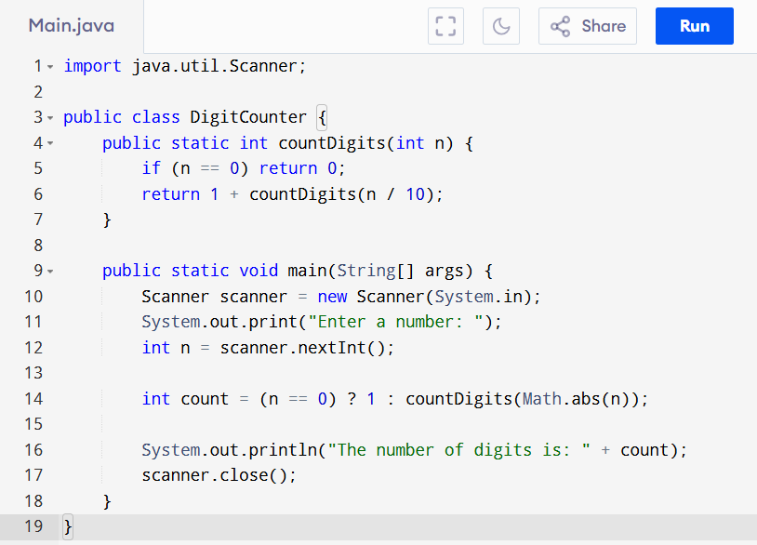

**Output:**

